1.
#include<stdio.h>

int main()
{
printf("Hello Linux\n");
return 0;
}
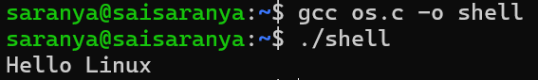
2.
#include<stdio.h>

int main()
{
char name[30];

printf("Enter your name: ");
scanf("%s",name);

printf("Welcome %s\n",name);

return 0;
}
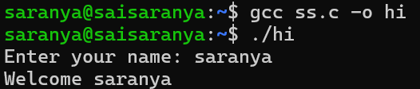
3.
#include<stdio.h>
#include<unistd.h>

int main()
{
printf("Process ID = %d\n",getpid());

return 0;
}
